**EVA – Educational Virtual Assistant**

Introduction

An **intelligent virtual assistant** is a software that can perform tasks or services for an individual based on commands or questions. A virtual Voice Assistant can be very useful for college as it can help with a variety of tasks related to academics. This Virtual assistant interacts with the user through voice commands or text messages. It can help students with a variety of tasks such as scheduling appointments, communicating with peers and professors, and even planning meals and workouts.

Problem statement

There is a need for a more efficient and convenient way for college students, faculties and visitors to manage their academic activities, and a lack of proper system for accessing information regarding college and it’s facilities.

Solution

EVA- Educational Virtual Assistant that utilizes a speech-to-text API that allows users to input spoken audio messages and generate corresponding output results.

When done in conjunction with a database foundation, the AI can be developed for providing personal assistance to people inside or visiting the campus. This is all done using a Flutter based Android App program and database management system. It also provides menu driven user interface using a series of screens or menus.

App design

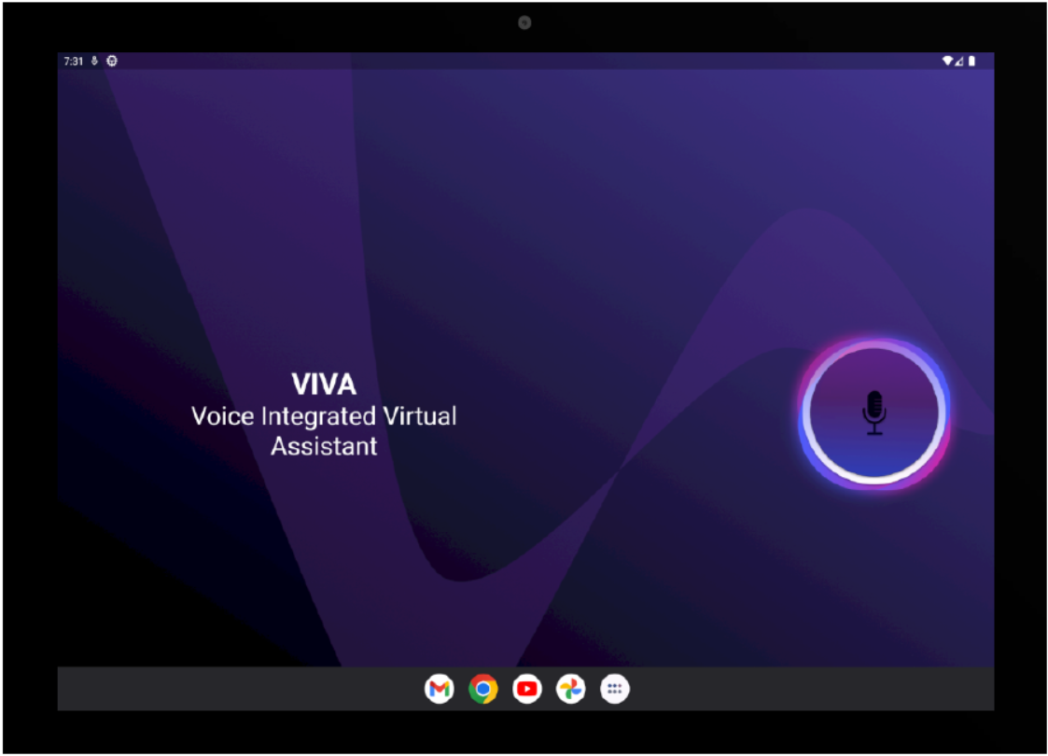

Questions

**Canteen**

* location
* menu
* opening , closing time

**Classroom/faculty/department**

* department-goals and objective
* What courses and programs does the department offer?
* What is the size and composition of the department?
* What resources and facilities are available to students and faculty in the department?
* faculty -qualification, department, post
* classroom-strength, location

**Facilities**

* drinking water ,toilet
* Location in each block
* seminar hall lab

**office**

* Sections

**Hostel**

* Number of wardens
* Warden details
* Total no of students
* Location
* Year wise seat availability

**gym**

* Trainer details
* Timing for girls and boys
* Opening and closing time

**Library**

* Location
* Approximately number of books
* Librarian
* Opening closing time

**Store**